

**Artificial Intelligence Project Final Report**

**Name :Nimagna Jain**

**Registration number: 11810789**

**Course Code: INT404**

Rubik’s Cube Solver

Abstract

Rubik’s Cube is an interesting puzzle which requires a player to arrange all the smaller cubes of same color at same face. This puzzle I very popular among mathematicians. A 3*3 Rubik’s cube has 43 Trillion combinations possible.

The program will take input of the current state of the Rubik’s cube and output the steps necessary to solve the cube.

Related Work

Finding Optimal Solutions to Rubik’s Cube Using Pattern Databases By Richard E. Korf

Implementation

This program can be integrated with the Arduino to automatically solve the cube.

Result

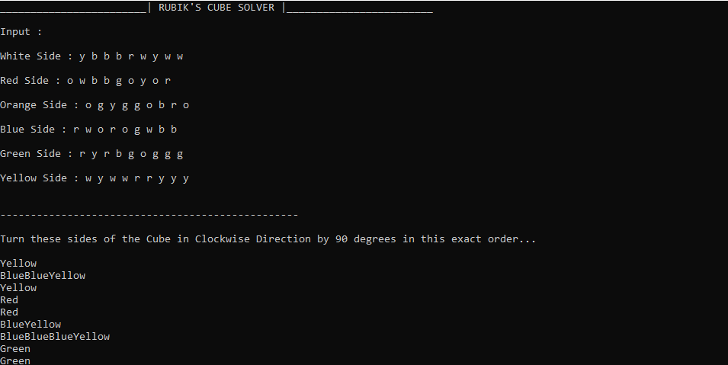

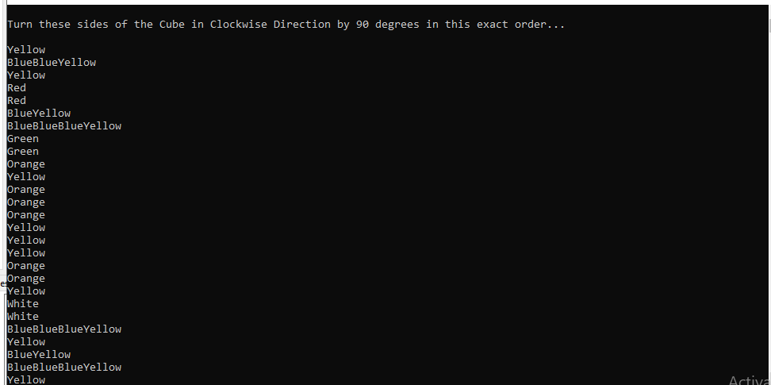

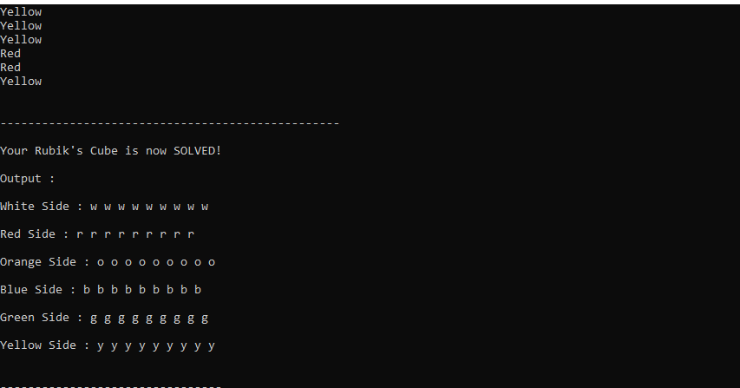

Work Distribution

No team member.

Libraries used

None

References

Research Paper: Finding Optimal Solutions to Rubik’s Cube Using Pattern Databases By Richard E. Korf